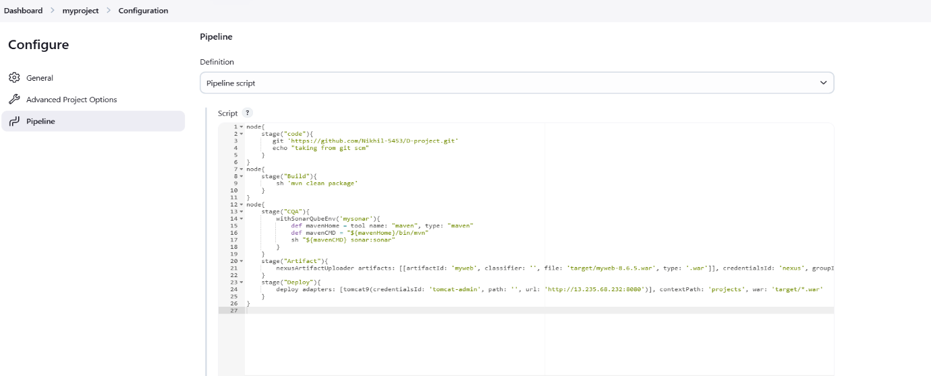
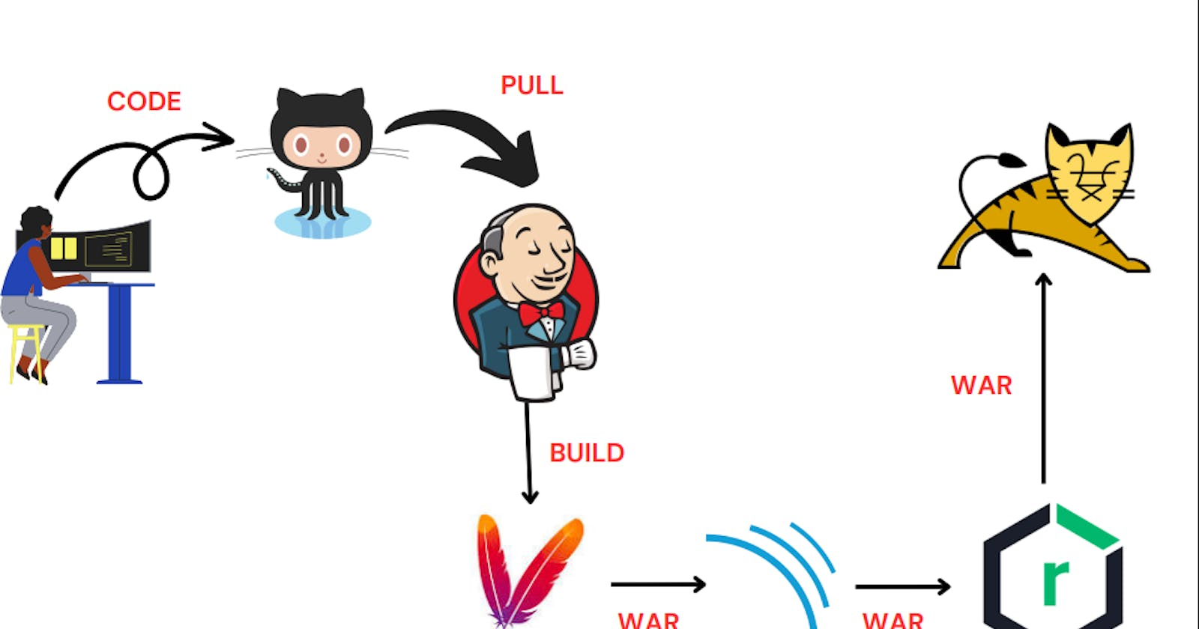

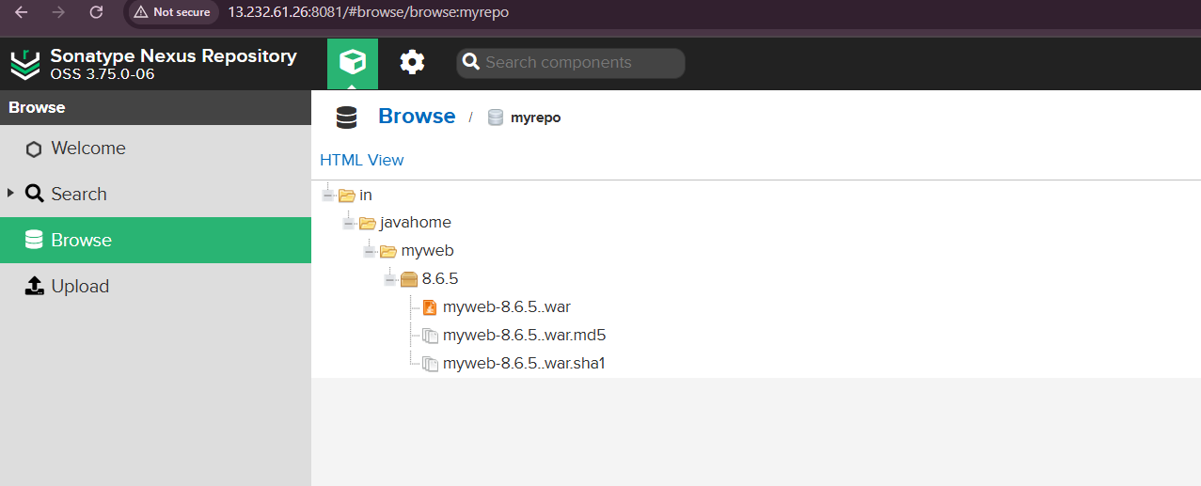

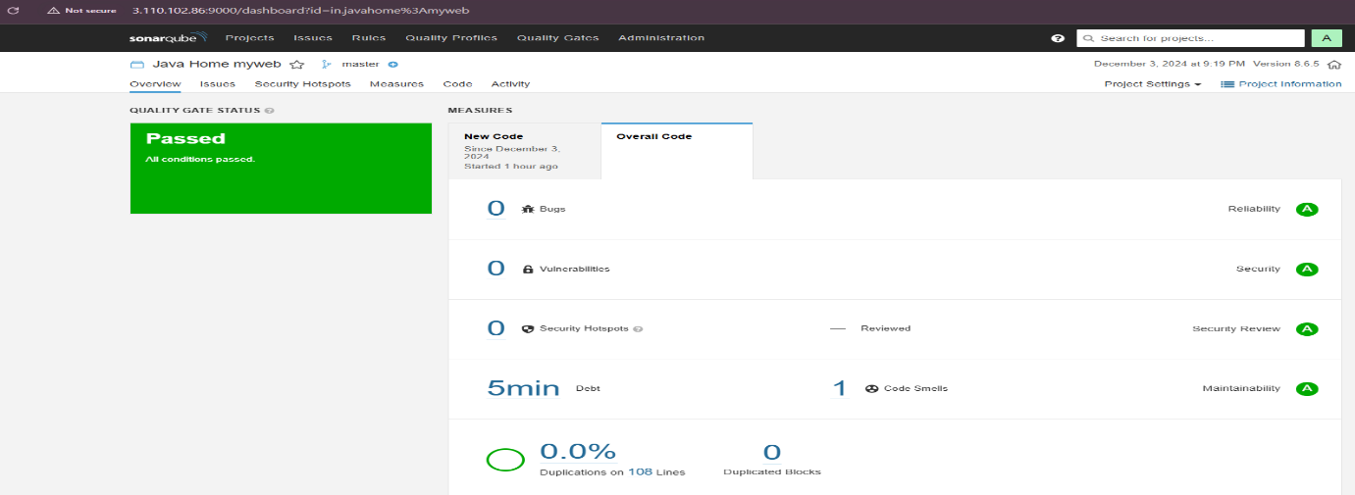

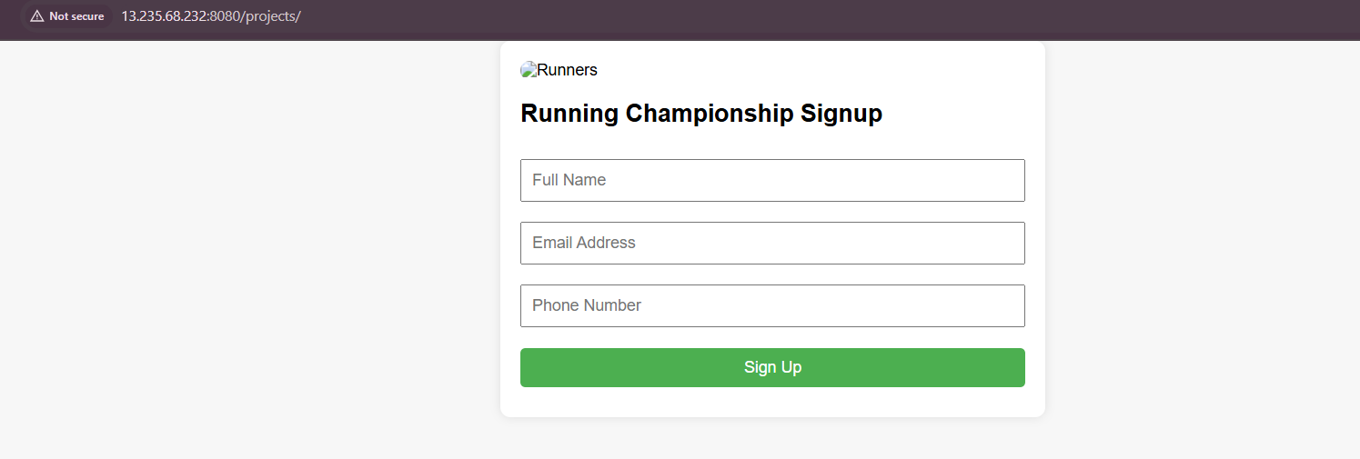

Pipeline Script:
node{
stage("code"){
git 'https://github.com/Nikhil-5453/D-project.git'
echo "taking from git scm"
}
}
node{
stage("Build"){
sh 'mvn clean package'
}
}
node{
stage("CQA"){
withSonarQubeEnv('mysonar'){
def mavenHome = tool name: "maven", type: "maven"
def mavenCMD = "${mavenHome}/bin/mvn"
sh "${mavenCMD} sonar:sonar"
}
}
stage("Artifact"){
nexusArtifactUploader artifacts: [[artifactId: 'myweb', classifier: '', file: 'target/myweb-8.6.5.war', type: '.war']], credentialsId: 'nexus', groupId: 'in.javahome', nexusUrl: '13.232.61.26:8081', nexusVersion: 'nexus3', protocol: 'http', repository: 'myrepo', version: '8.6.5'
}
stage("Deploy"){
deploy adapters: [tomcat9(credentialsId: 'tomcat-admin', path: '', url: 'http://13.235.68.232:8080')], contextPath: 'projects', war: 'target/*.war'
}
}

